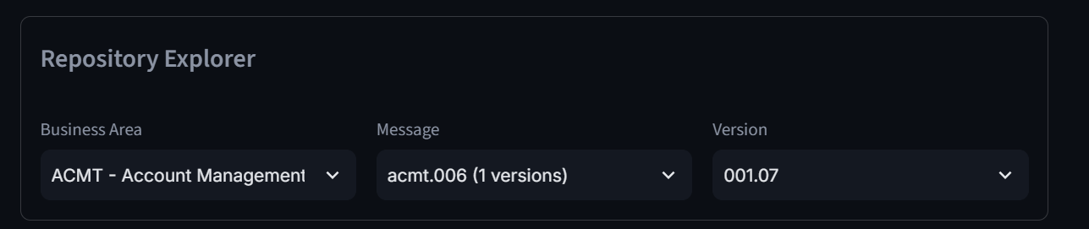

The C:\PaymentStudioAssets\Repository\archieve\acmt location contains all version including historical

This loction contains current on “C:\PaymentStudioAssets\Repository\ACMT”
Ask is keep the current one as default, bit in dropdown and count one should have option to generate Samples… same doe all PACS And Pain Messages

Hoe to enhance and Map below
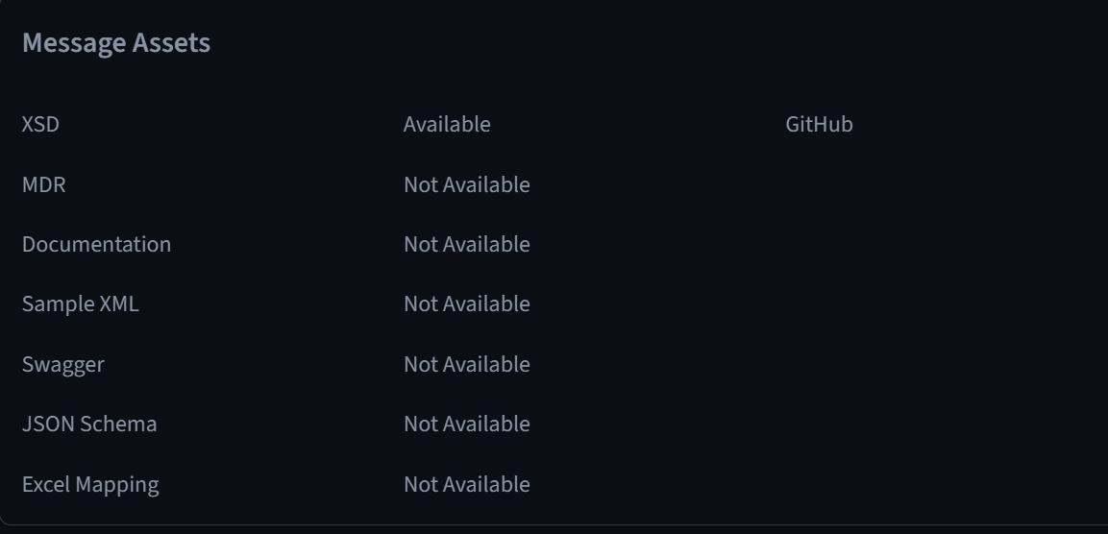

3. Option for user to download the XSD in their local Machine
4. How to Map MDR to message categories as they are generic, Also need option for users to download MDR’s, need a way ti show user which MDR is for which message types
5. We should also give option to upload his own version of XSD so he can generate Sample as per his requirement
6. Most of the value of sample is marked as “X” , we should take maximum values from JSON and then map that to message. For rest we should make its as customer input or system input, from which ever source this value is expected.
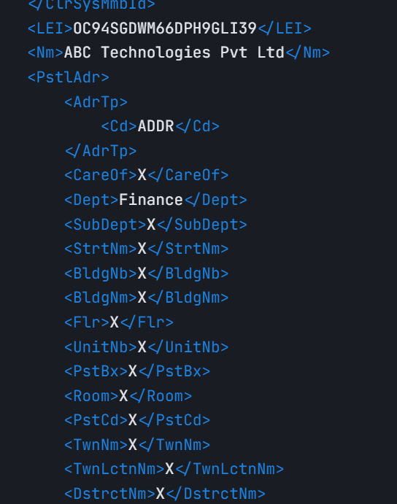

And most important its currently working from local machine, specially all code and XSD are on this Laptop. How can I make it web based so other can use it.
The XSD in PaymentStudioAssets are approx. 600MB, can we put that in Git

